
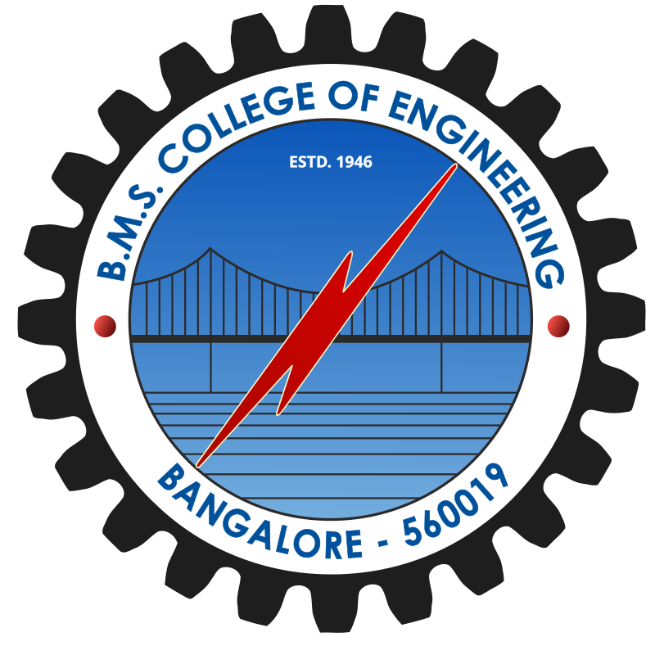
B.M.S. College of Engineering
(Autonomous Institute, Affiliated to VTU)

ADMISSION TICKET
Semester End Examinations -Dec 2025 /Jan 2026(Reappear/Re-Registered)

NAME OF THE STUDENT : RIJUL BHARDWAJ
DEPARTMENT : Electronics and Communication Engineering
PROGRAM : B.E
USN : 1BM21EC129

SEMESTER : 8

Sl No. | COURSE CODE | COURSE TITLE | ELIGIBILITY | INVIGILATOR  SIGN.
1 | 22EC3PCAEC | Analog Electronic Circuits | Eligible
2 | 22EC4PCFAW | Fields and Waves | Eligible
3 | 22EC6PCMSD | Mixed Signal Design | Eligible
4 | 22EC5PCFOV | Fundamentals of VLSI | Eligible

Candidate's Signature Controller of Examination
INSTRUCTIONS TO THE CANDIDATES

- Check the examination hall ticket carefully. Ensure the eligibility of your exams.
- Follow the instructions printed on the facing sheet of your answer booklet and hall ticket.
- Bring your Student ID Card and Hall ticket during the examination. You will not be allowed to enter the examination hall without these.
- Do not bring any unauthorized material like electronic gadgets, Mobile Phones, written materials, or any sort of materials that may lead to malpractice, the same will be checked, confiscated, and will be booked under malpractice.
- Arrive at least 15 minutes before the start of the examination. As you enter, show your Student ID card.
- Listen carefully to instructions. Students are required to comply with the instructions of invigilators at all times.
- You will NOT be allowed to enter the examination center 30 minutes after the start of the EXAMINATION.

